Java program 21 to 25

21

//this is a program for wrapper class

public class WrapperClass1

{

public static void main(String[] args) {

System.out.println("For integer ");

int a =20;

Integer i = Integer.valueOf(a);

Integer j =a;

System.out.println(a+" "+i+" "+j+"\n");

System.out.println("For double ");

double b = 45.777D;

Double k = Double.valueOf(b);

Double l =b;

System.out.println(b+" "+k+" "+l+"\n");

System.out.println("For character ");

char c = 'j';

Character m = Character.valueOf(c);

Character n =c;

System.out.println(c+" "+m+" "+n+"\n");

System.out.println("For float ");

float d = 52.0F;

Float o = Float.valueOf(d);

Float p =d;

System.out.println(d+" "+o+" "+p+"\n");

}

}

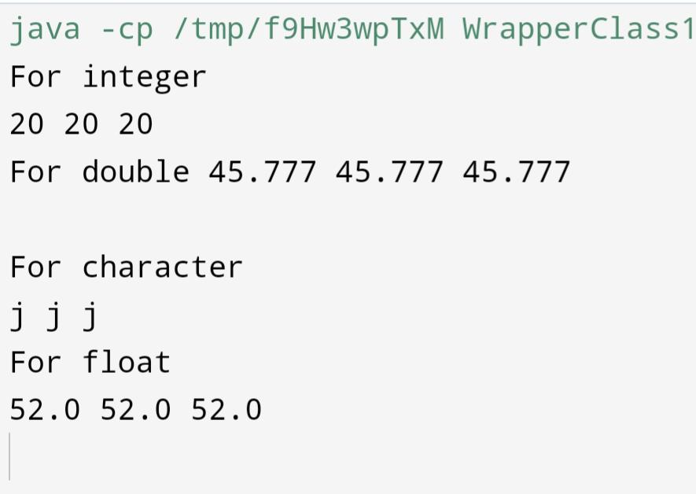

Q 22

//this is a program for unboxing

public class WrapperClass2

{

public static void main(String[] args) {

Float a = new Float(43.8F);

float i = a.floatValue();

float j = a;

System.out.println(a+" "+i+" "+j);

Integer b = new Integer(43);

int k = b.intValue();

int l = b;

System.out.println(b+" "+k+" "+l);

Character c = new Character('a');

char m = c.charValue();

char n = c;

System.out.println(c+" "+m+" "+n);

}

}

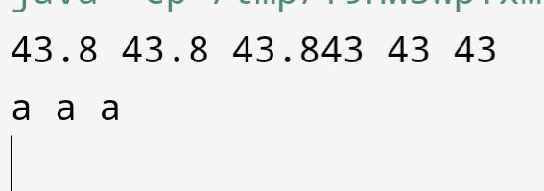

Q 23

//this is the demonstration of toString() method

public class Student{

private String name;

private int rollno;

private String department;

//these are class variables or instance variables

Student(String name, int rollno, String department){

//these are local variables

this.name=name;

this.rollno=rollno;

this.department =department;

}

public String toString(){

return name+" "+rollno+" "+department;

}

public static void main(String [] args){

Student s1 = new Student("Jahanvi ",69,"CSIT");

Student s2 = new Student("Ram ",98,"CSIT");

System.out.println(s1);

System.out.println(s2);

}

}

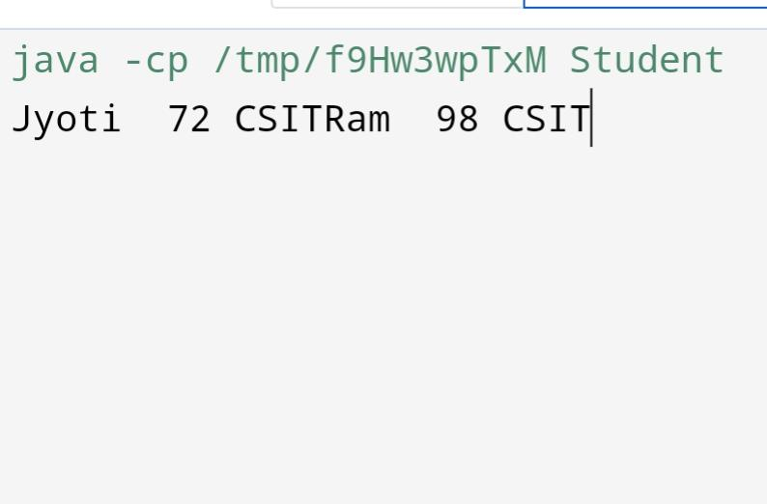

Q 24

public class MyClass{

public static void main(String [] args){

for(int i=0;i<args.length;i++){

System.out.println(args[i]);

}

}

}



Q no 25

Public class Triangle{

int a,b,c;

public double getArea(){

double s = (a+b+c)/2.0;

return Math.pow((s\*(s-a)\*(s-b)\*(s-c)),.5);

}

public double getPerimeter(){

return (a+b+c)/2.0;

}

}

class Ans{

public static void main(String[] args){

Triangle t = new Triangle();

t.a = 2;

t.b = 5;

t.c = 6;

System.out.println(t.getArea());

System.out.println(t.getPerimeter());

}

}

Q no 26

Class Rectangle{

Int length;

Int breadth;

Public Rectangle(int l, int b){

Length = l;

Breadth = b;

}

Public int getArea(){

Return length\*breadth;

}

Public int getPerimeter(){

Return 2\*(length+breadth);

}

}

Class Ans{

Public static void main(String[] args){

Rectangle a = new Rectangle(4,5);

Rectangle b = new Rectangle(5,8);

System.out.println(“Area : “+a.getArea()+” Perimeter is +a.getPerimeter());

System.out.println(“Area : “+b.getArea()+” Perimeter is +b.getPerimeter());

}

}

Q no 27

Import java.util.\*;

Class Complex{

Int real;

Int imag;

Public Complex(int r, int i){

Real = r;

Imag = I;

}

Public static Complex add(Complex a, Complex b){

Return new Complex((a.real+b.real),(a.imag+b.imag));

}

Public static Complex diff(Complex a, Complex b){

Return new Complex((a.real-b.real),(a.imag-b.imag));

}

Public static Complex product(Complex a, Complex b){

Return new Complex(((a.real\*b.real)-(a.imag\*b.imag)),((a.real\*b.imag)+(a.imag\*b.real)));

}

Public void printComplex(){

If(real == 0 && imag!=0){

System.out.println(imag+”I”);

}

Else if(imag == 0 && real!=0){

System.out.println(real);

}

Else{

System.out.println(real+”+”+imag+”I”);

}

}

}

Class Ans{

Public static void main(String[] args){

Complex c = new Complex(4,5);

Complex d = new Complex(9,4);

Complex e = Complex.add(c,d);

Complex f = Complex.diff(c,d);

Complex g = Complex.product(c,d);

e.printComplex();

f.printComplex();

g.printComplex();

}

}